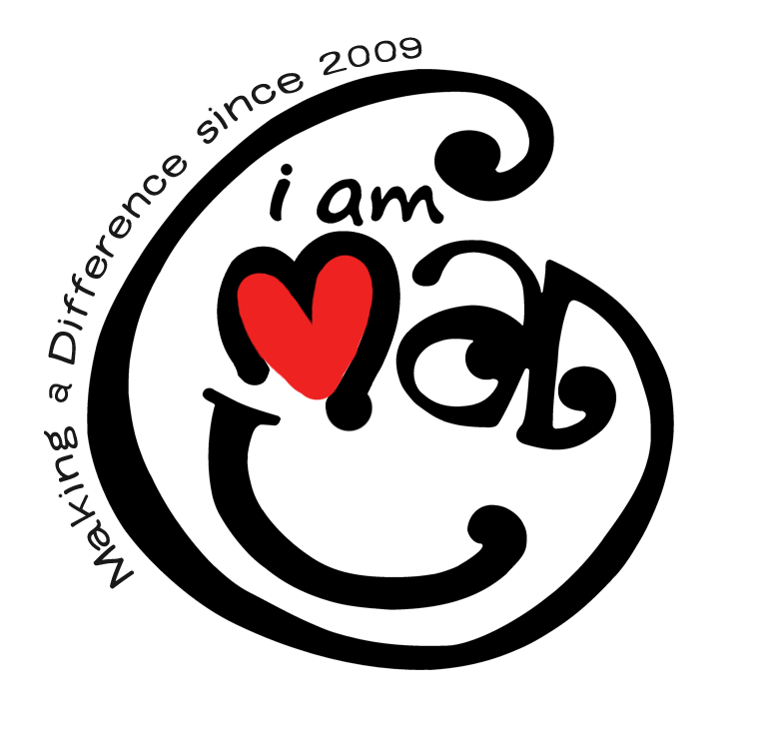**PRESS RELEASE**

**‘I am MAD’ hosts forum on mental health, volunteerism**

In its third year of promoting safe spaces for mental health discussions, nonprofit organization **I am MAD (Making A Difference) Volunteers, Inc. (I am MAD)** will host a forum on mental health and volunteerism at Cinema 6, SM Megamall, Mandaluyong City, on October 19.

This initiative comes in light of recent findings indicating that mental health issues are among the top five reasons for dropout rates among higher education students in the Philippines.

Titled **MAD Talk Padayon**, the event coincides with World Mental Health Month and aims to highlight stories of resilience and the positive impact of volunteerism on mental well-being.

“The primary goal of the event is to create a safe space for volunteers to share their personal journeys of pain, love, healing, and growth,” said ***Kaye Maguddayao, Project Lead of MAD Talks Padayon***. She emphasized the importance of prioritizing mental health and seeking help.

#### The healing power of poetry

MAD Talks Padayon will feature selected readings from *Mga Tala at Tula*, a poetry collection by renowned Filipino author Ron Canimo, known for capturing the depths of human emotion. His organization Mga Tala at Tula Community won as one the Ten Accomplished Youth Organizations in the Philippines (TAYO) in 2020 for introducing the beauty of poem writing to the new generation and imparting love, hope, healing through poems and creative writing.

Actor and influencer Sky Quizon will also share messages of hope and insights on volunteerism.

Dubbed the “Ultimate Hugot” event, this initiative is a collaboration with **SM Cares**, the social responsibility arm of SM Supermalls, and the **National Youth Commissio**n, designed to engage diverse audiences nationwide. The theme will focus on the journey of volunteers, captured in the phrase: “*Nagmahal, Nasaktan, Nag-volunteer at Padayon.*”

#### Inspiring voices of volunteers

This year’s lineup of speakers features Jao Jundam, a nursing board exam topnotcher and Volunteer Lead for International Relations, known for his viral story of taking on odd jobs before becoming a nurse in Australia. Also speaking will be Jake Villanueva, Volunteer Lead for Content Creation and University Extension Specialist from UP Diliman; Kaye Chia, Team Lead for MAD Camp Aurora and student leader from Manila Tytana Colleges; and Ymari Kristia Pascua, a mental health coach.

Tickets are available for as low as Php 99.00 at bit.ly/MADTalksPadayon2024, with a portion of proceeds benefiting learner-participants of the MAD Camps program for 2025.

MAD Talks Padayon is supported by SM Cares, Youth Organization Registration Program (YORP) of the National Youth Commission, and The New Channel. The forum aims to inspire meaningful dialogue, providing actionable strategies to support mental health through volunteerism. It seeks to empower individuals to take charge of their mental well-being while contributing to societal good.

Support the organization by donating at bit.ly/bidadonate. For updates and partnership opportunities, email iammadph@gmail.com. Follow I am MAD on Facebook (fb.com/IamMakingADifference), Instagram/X/TikTok (@iammad_ph), YouTube (youtube.com/@iammadvolunteers), and listen to their podcast at anchor.fm/iammad or bit.ly/MADTalksSpotify.

**(END)**

*\*Written in collaboration with Allysa Fernandez, Jake A. Villanueva, and Wino Dela Cruz*

**About I am MAD (Making A Difference) Volunteers, Inc.**

**I am MAD (Making A Difference)** is a nationwide, volunteer-powered non-profit organization focused on mobilizing the Filipino citizens, especially the youth in helping empower our younger generation to discover their dreams and passions, adopt a more values-oriented mindset, and eventually make a meaningful contribution to nation-building.

I am MAD believes that even through our smallest positive habits and simplest acts of volunteerism, we can contribute to the betterment of our society.

The organization has been twice recognized as one of the [**Ten Accomplished Youth Organizations (TAYO)**](https://www.youtube.com/watch?v=OfsIIXLOlWs&feature=youtu.be)awardee in 2015 for its main program [**MAD Camp**](https://youtu.be/r52e5BTdxyw)(under the Culture and Arts, Peace, and Human Development category); and a national finalist in 2018 for its [**MAD Talks events**](https://www.facebook.com/TAYOawards/videos/10156034456877103/) (under the Culture, Arts, and Heritage category).

For more information, visit: [fb.com/IamMakingADifference](http://fb.com/IamMakingADifference) | [instagram.com/iammad_ph](http://instagram.com/iammad_ph) | [twitter.com/iammad_ph](http://twitter.com/iammad_ph) | [youtube.com/@iammadvolunteers](http://youtube.com/@iammadvolunteers) | [anchor.fm/iammad](http://anchor.fm/iammad) | [bit.ly/MADTalksSpotify](http://bit.ly/MADTalksSpotify) | [tiktok.com/@iammad_ph](http://tiktok.com/@iammad_ph) | Email: [iammadph@gmail.com](mailto:iammadph@gmail.com)

**=================================**

*For media inquiries, contact:*

**Erwin Dela Cruz | Wino Dela Cruz**

Chief of Volunteer Programs & Communication

**​I am MAD (Making A Difference) Volunteers, Inc.**

+63 908 817 6049 | [erwin.edc@gmail.com](mailto:erwin.edc@gmail.com)